
University of Arkansas – CSCE Department
Capstone II –Final Report – Spring 2012

Angry Prims
Christian Williams, Francis Sabado, Aaron Mahmoud

Abstract

User motion and voice interactive games in a virtual three-dimensional environment require a significant change of perspective to the current paradigm of discrete and isolated computer games, and as such there is a problem of how to implement such games. The “how” of the implementation and limitations of such games and simulations is the objective of this project. Implementation of such games will require the merging of several technologies running across various platforms utilizing multiple programing and design paradigms and patterns.

1.0 Problem

The Kinect device is able to record a user’s movements and voice commands of users current physical location. Mapping those user gestures to objects in a simulated environment introduces various problems and challenges. Integration of the user into the simulation is the chief problem of such applications, especially when the goal of the application is to play a game or to otherwise engage in a productive activity. Specifically in the real world, an engineer may struggle with building a framework to join two different technologies and two different paradigms such as mapping real world three dimensional movements to virtual world movements which may not be directly encapsulated within a virtual avatar but instead spread out over multiple disconnected objects. Similarly games create situations and objects that range from real situations and real physical items to situations and items that have never existed and possibly never could exist and yet the user is expected to be able to interact in the environment as close to it as effectively as if it were the real world.
Modeling two dimensional objects and user movement and voice commands are two activities that the Kinect should be able to capture and then simulate via user interaction. Determining what gestures are connected to what actions and the fidelity of the motion event capabilities that Second Life with the Kinect can produce is the main problem that this project is attempting to answer via direct implementation. This direct implementation for the project explored the concept of game play as it relates to the interaction between the user, Kinect, and Second Life.

2.0 Objective
Set up, by means of client and server methods, and allow for various users to access Second Life for the purpose of playing a game that models the popular angry birds game with a three dimensional variation where user motion and voice commands are captured by the Microsoft Kinect device.

3.0 Background

3.1 Key Concepts

The virtual world of Second Life is a computer generated environment modeled to simulate the real world. In Second Life there are constructs to simulate land for users to walk on as well as objects called prims for users to interact with and to construct representations of real world objects. The combination of land and prims create an environment where users, via avatars, can explore, create and interact with objects both familiar and different and in any combination of order and location. This project used Second Life as the end destination for user interaction. Limitations of Second Life include the amount and scale of objects that may be modeled which directly relates to the fidelity, high-quality reproduction, of which the simulated environment can be made to replace the real one.
The Microsoft Kinect is a sensor that allows for the three dimensional capture of an object and its environment by recording its RGB light, depth distance information and sound. The sensor is linked to a computer program which can then record and manipulate the data from the sensor for the purpose of some goal. The main goal of the sensor is to record the speech and actions of user and allow them to further integrate into a virtual game world. Limitations of the Kinect sensor include the degree to which the sensor can understand the fine details of user input. An example is that while the sensor can understand clearly large movement of the human body it has trouble understanding small details such as finger movements.

3.2 Related Work
Microsoft and partner game studios have created a host of purpose built simulated environments for interaction between users and objects using the Kinect sensor [1]. Kinect has also been integrated into Second Life Viewer by Merov Linden. Mitch Kapor and Bossut wanted to create a hands-free 3D camera interface for Second Life and have been able to capture simple avatar actions using the Microsoft Kinect [2]. In addition, MxR Lab at the University of Southern California Institute for Creative Technologies has been able to connect Microft Kinect and Second Life using the OpenNI toolkit. Thai Phan, an engineer at the MxR Lab, developed a system that recognized real life social gestures through the Kinect and was able to control an avatar in Second Life [3].

4.0 Design

4.1 Requirements
- Kinect Client service running local to a Kinect device for user interaction.
- Intermediate server used to link the user to the game engine environment.
- Server containing game logic components and state information about the current user and activities
- A game engine environment in Second Life that gives visual confirmation to the user and directs the user towards a game winning condition.

4.2 Architecture

The overall design of the project is:
A Kinect client service running local with a Kinect device for user interaction sends event data to an intermediate server that determines which commands to issue to smart objects in second life. One main part of the design of this project is the intercommunication of a user to the Second Life environment and vice versa. The client service records all user interactions and matches them to appropriate commands which are sent as tasks via the server or directly from the client to the correct objects in Second Life. Thus the client contains a group of components that handle communication between the user, Second Life environment, and the intermediate server. It also includes game logic comparison components that determine appropriate event actions from the user. Finally the server houses all state related components to ensure state information is saved in an associated database and other data structures while freeing up the client to focus on user interaction events and minor non-persistent state changes.
Due to the design of Second Life and the tendency for Second Life Uniform resource location, SLurl, to expire for reasons not directly related to the project, one vital component to the design is the use of an intermediate server. The server allows objects in Second Life to advertise themselves to any requesting client that utilizes the required request protocol. The advertisement is in the form of a name and SLurl item pairs. These stored SLurls could then be invoked with arguments to execute certain actions from objects in Second Life known as “prims”. In addition, the intermediate server also stores state information for all game level designs that is then sent to Second Life for object rendering.
The Second Life environment consists of existing functionality such as modeling methods that is used as the ending point for user actions. In addition to the prebuilt functionality, Second Life also provides a way to communicate between the server and prims for action instructions and command results. State changes within the Second Life environment is recorded by a score tracking object that work in tandem with head’s up display or HUD objects. HUD objects provide visual cues to the user about game conditions, scoring, and prim status.

System Interaction Drawing
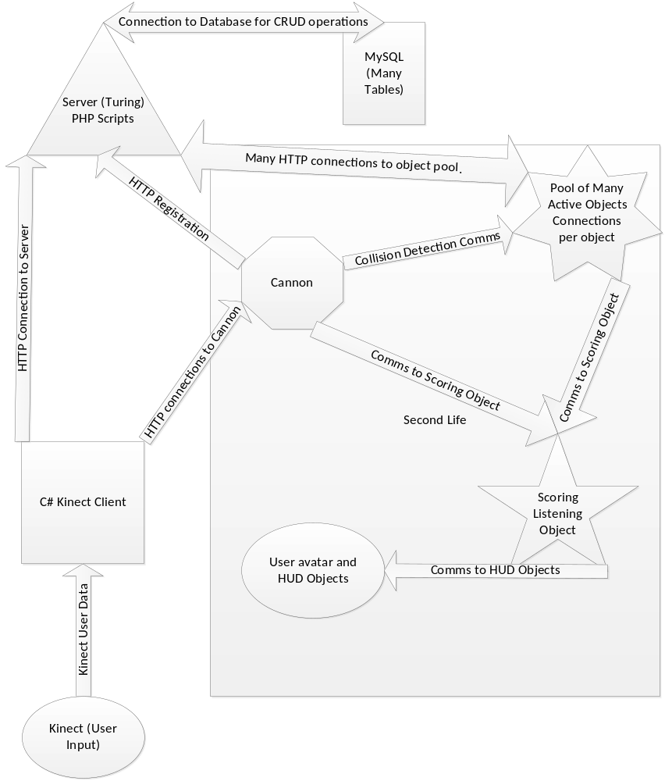

Communication and Data Manipulation
The design of the project was based around the Second Life concept of URLs for specific objects located in Second Life. The design called for protocols that utilized standard web request embedded message passing to communicate from client to and from server, server to and from Second Life, and client to and from Second Life. Due to the digital nature of TCP backed protocols such as HTTP post requests, some difficulties were encountered with regard to making actions in Second Life appear to be continuous. One work around to this was to use more request. However, this solution was unsatisfactory because Second Life places a limit on the number of requests that any one URL can accommodate in a specific time span such as 25 requests per 20 seconds or 1 per second sustained. After considering that most games have a 60 frame per second rate, it becomes clear that relying on the SLurl would yield unsatisfying results at best. Using a protocol such as UDP would be the ideal but this author is unaware of any prim to UDP functionality existing in Second Life without modifying the Second Life client itself. One possible work around here is the interaction of the data sent by the user and a script in the prim itself which would smooth the appearance of the discrete chucks of data by the Post request.
The PHP registration server worked well to enable Second Life to post its current state, show available prims for interaction, and allow for a client to establish communication with Second Life. Prebuilt game states, where a set number of prims could be constructed and then have their current states captured by a registration service such as the one used by the model game, are being used with great success. The entire state of multiple prims can be recalled and reinitialized to a previously designed steady state (Map) after initial design and construction thus negating the need to rebuild any complex situation and even having the possibility of associating a time component with the state so that the situation could be reconstructed and simulated as well. The Maps are able to be independently constructed during the design phase of the project and then stored in the database memory residing with the intermediate server in relational database table form. When called, the server would form pairs of properties from one table to an associated prim URL and direct that property data to be sent to specific SLurls within the Second Life environment to recreate a prior built Map on command. The server also had the ability to clear the game area where the Map was created by directing all of the objects to a predefined location that was out of the immediate area as determined by Map0, a special one record map which held the location to the waiting area for the pool of active objects in Second Life.
Kinect Interaction
The Kinect sensor is able to detect movement and position based gestures and speech. The movement based gestures required the starting of what Microsoft calls NUI runtime which is a constantly running data capture scheme where a skeleton has various points that correlate to the average user’s body. These points have data that is associated with the X, Y and Z positions of the real world as observed by the Kinect device. The Kinect populates the data for every point and signals that the skeleton is ready to be read by the client program. This cycle repeats at a rate of about 30 frames per second unless complex calculations are attempted on the NUI thread. All gestures have to use either the data directly or have some mechanism in place that can observe and compare recorded data with current data and arrive at a predefined gesture event. This project utilized direct data use due to the constraints of HTTP communications which were acting to delay interaction in addition to any delay which would have been caused by gesture events. Three body joints were tracked by the Kinect to calculate the cross product and dot product to obtain two values from which an atan2 (variation of the arctangent function) calculation can be made. Atan2 correlates the ratio of the cross product length (the Z-axis of the cross product calculation) with the value of the dot product to form the angle in radians between the body segments. The radians are then converted to degrees and sent to Second Life for the cannon to respond with the given angle. The speech events are generated similarly to the gesture events but the audio of the user was compared against a language that was loaded into the speech recognition engine. This speech was compared by the engine to see if the audio track recorded matched any of the words in the known language. If the word was matched beyond a user defined confidence interval, the program defined event was executed. In the AngryPrims program, the game state is primarily controlled by speech which would enable map transitions. The map transitions also caused the HUD objects to receive reset commands which would then signal to the user that the game was in a ready state.

User Interaction Design
The user of the game is tasked with observing a group of objects that were placed in their line of sight in a predetermined order and then interacting and controlling one of those objects, called a cannon object, for the purpose of knocking down the rest. This seemingly simple game presented multiple challenges such as how would the user know how to interact with the Kinect device to get the prim cannon object to change its relevant properties and orient itself and what are the sequence of steps the user must conduct in order to reach a victory condition. For the first problem, user is assumed to be familiar with the rules of the game from instructions provided. The second problem is solved by allowing the user to interact with the game in any manner they wished but with the constraint that only certain actions would correspond to events in the game. For selecting the current map or to fire the cannon, a speech event by the user worked well. Controlling the orientation of the prim cannon was accomplished by shadowing the movements of the user’s hands and transmitting the data from the client to the cannon in Second Life.

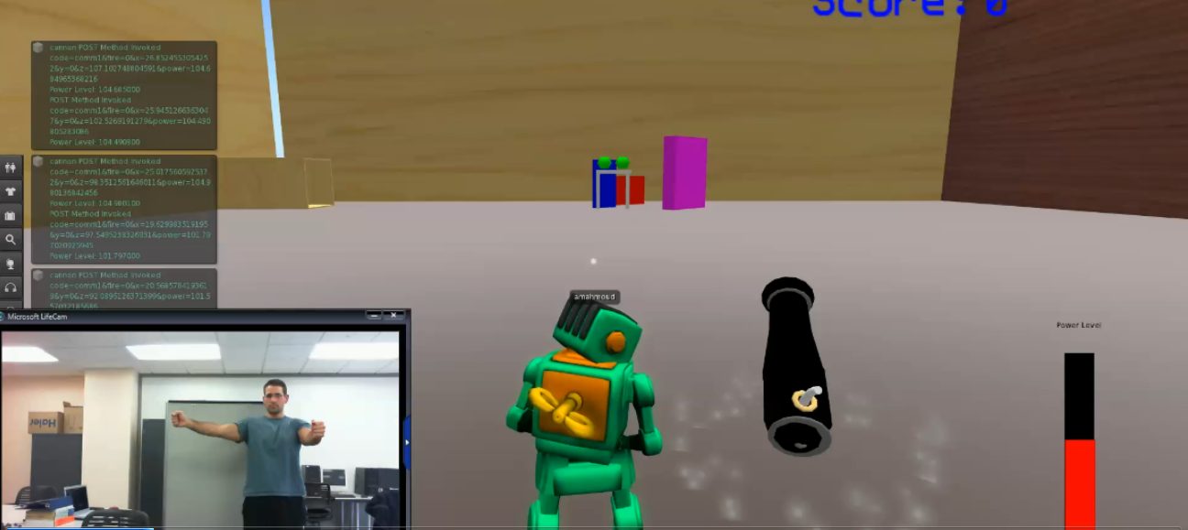
Cannon and Power level manipulation
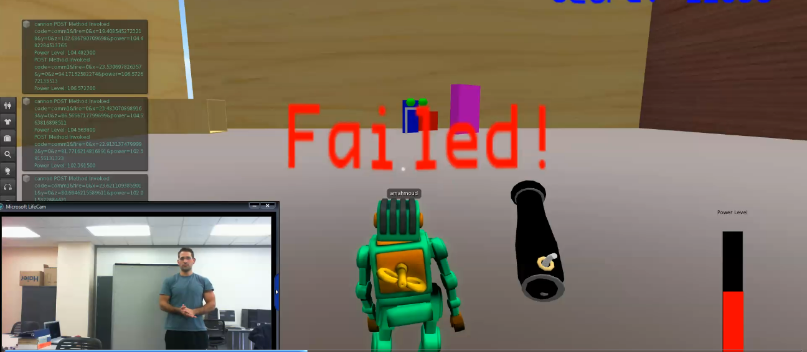
Failing to clear the map gives the losing condition.
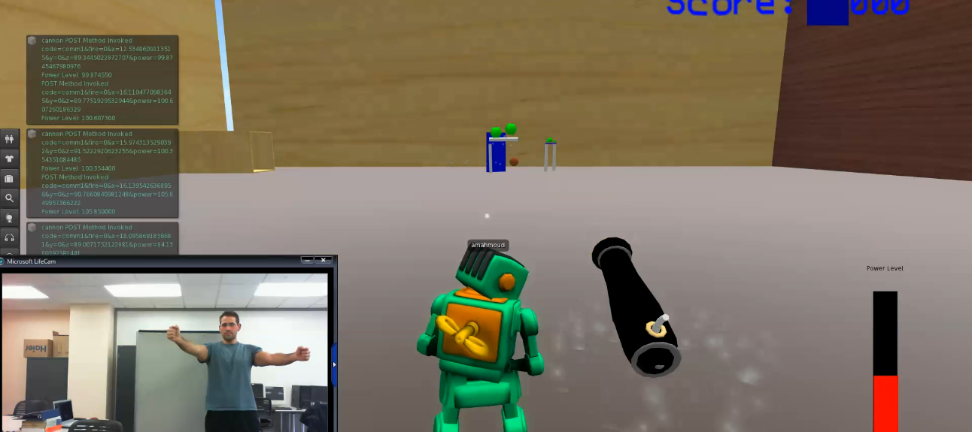
Firing at the map to destroy objects
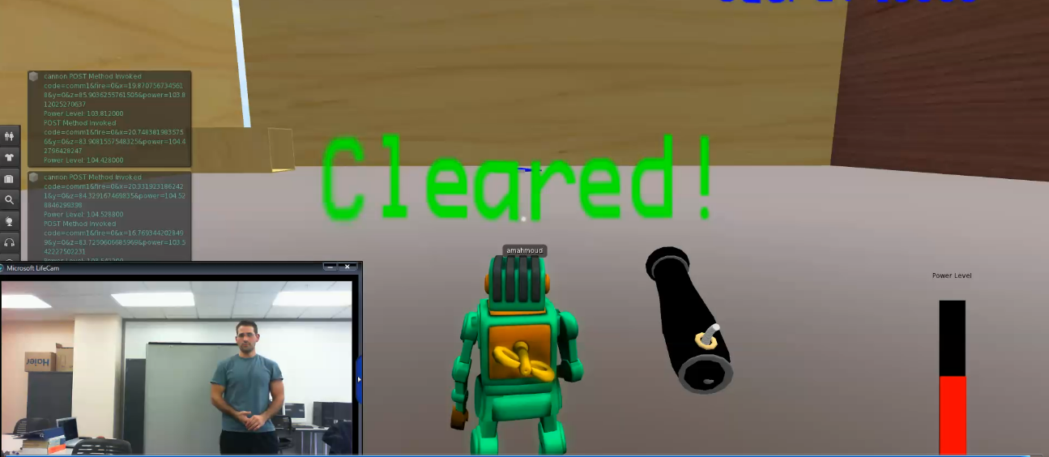
Clearing the map of enemies creates a winning condition

Technology and Implementation
The client for the project was built using Visual Studio 2010 and the C# programming language. The use of this integrated development environment and language allowed for the use of the software development kit provided for the Kinect sensor by the Microsoft Corporation. The implementation of the client was based loosely on a state machine type of design. The inputs could be either voice commands or gestures by the user which would then change the state of the program and cause commands to be sent over HTTP requests to either the server or to Second Life, depending on the specific state of the client program. The HTTP requests were asynchronously sent using asynchronous delegates, a multithreading paradigm, avoiding program slow down due to response time.
The server was a simple PHP script that read incoming HTTP requests for control messages and data, and then executed the desired response by function calls to the requested methods. The persistence of memory for the PHP server was provided by a MySQL database which when accessed by the PHP script gave the server state memory of the current conditions within Second Life, specifically what objects were and were not available to be interacted with by the user and the server. When combined, the PHP and database served as a mechanism to establish a game by contacting Second Life and conducting map transitions for the user. The server also established the client initial state by feeding it the current address of the main user interaction object, the cannon.
The Second Life environment is a very large and complex software and hardware construct that serves to act as the game environment for the project. It was chosen for its ability to conduct large user interactions on virtual physical objects of the type used in this project. The majority of the functions of the Second Life environment are beyond the scope of this project and hence this report. The important things to note about the use of this independent environment are that it is developed and supported by an external party and as such development time was not needed to be spent focusing on the computer display for the output of the project. Also the environment provided lots of coding assistance and ways to interact with the objects by the use of the Second Life Scripting Language. This local logic allowed the server to just focus on specific user interactions without having to handle every object to object interaction. The result was a faster response to user events and less loading on the server.
Cannon and Bullet Mechanics
Second Life provides a sophisticated game engine that supports complex physics and object interaction. The use of Second Life in the implementation process of our design allowed greater degree of control. Game mechanics were mimic from a popular game Angry Birds, utilizing game aspects such as trajectory, projectile, collision detection, and animation. The most notable simulation of these game aspects involves the cannon and the bullet. As discussed earlier, the cannon is the Second Life object by which the user interacts with the virtual world. The cannon receives varying commands from the server via HTTP request and acts accordingly depending on the command type and arguments. The figure below shows the cannon and the bullet objects in Second Life.
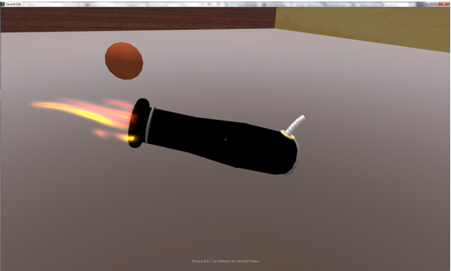
There is a complex interaction between the cannon and the bullet. One of the requirements of the AngryPrims project is a game that facilitates the interaction between Kinect and the user. The user is able to fire, manipulate rotation, and modify cannon power level. Firing of bullet is achieved through the exploit of the llRezObject function on SecondLife. This function allows object to receive a velocity through a vector data in x,y,z direction of the grid. Second Life contains data types called vectors which hold 3 values, x,y, and z and have the form <x,y,z> . The x,y,z values of the vector depends on the current orientation of the game stage. Furthermore, manipulation of this velocity direction were found to be simplified if the direction followed a straightforward values of only x,y,z and not any combination. For example, having the direction follow the x-axis or a vector value of <1,0,0> proved to be an easier calculation for the project than a value of <.5,.5,0>. After determining the velocity vector, a velocity is multiplied to this vector to find the final velocity vector. Unfortunately, Second Life has a limitation in this aspect of the game. According to the Second Life documentation, there is a maximum value of 200 m/s for the velocity. Upon rezzing a bullet object from the cannon, the bullet object travels through the virtual spaces where game physics take over. Second Life documentation states that the gravity is 9.8 m/s². Second Life gives us further degree of control by changing the gravity coefficient on the object. Due to the acting force of gravity, the bullet follows a parabolic trajectory similar to the figure below.
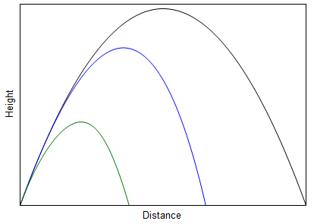
Heads Up Display Design (HUD)
The Angry Prims project consist of 3 different HUDs. At the current stage of development, they are all separated to reduce the complexity of the project. Model-View-Controller software design was used for the design of the HUD objects. Future work on the HUD would be integrating them into one and expanding the feature set.
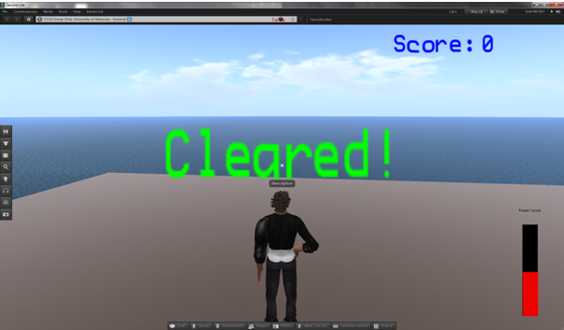
Located on the bottom right of the screen, the power level shows the user the current power level of the cannon object in SecondLife. The red bar denotes the power level; full red bar means a power of maximum 200m/s while an empty bar indicates a 0 m/s. This is automatically updated as the power level changes. Located at the top right of the screen, the score HUD shows the current score of the user for the current session of the Angry Prims game. This automatically changes as shots are fired and objects are destroyed on the field. It is capable of indicating negative and positive values. The current setup allows a maximum score of 6 digits to show correctly. Higher scores require minimal shifting of the text to the left to show more digits. The maximum allowed digit is currently 20. The scoring system is all done on the server. This means that the score HUD only receives message and does not control any aspect of the game condition. The game message HUD is located on the center of the screen to indicate the current status of the game condition. There are currently two available messages to the user. There is an infinite amount of message allowed. Current messages include:
Win Condition: "Cleared!"
Losing Condition: "Failed!"
At the beginning of game session, the game message HUD is transparent to the user. The message changes only after receiving a command from the game controller. The HUD design was created to improve gameplay and provide feedback to the user.
Game Mechanics and Animation
The map generation component is an important aspect of the Angry Prims project. The dynamic creation of map variations allowed a more sophisticated gameplay. This component of the project was achieved by expanding a past project called Object Modeling game. The Object Modeling game was developed by Francis and Christian during artificial intelligence class. The project used unit objects called Smart Objects that had the ability to receive messages from the server and change object properties via HTTP request. This capability allowed objects to change to different variations depending on argument sent to it. These smart objects were expanded to include collision detection mechanism as explained earlier. There is an infinite amount of smart objects allowed to generate maps in the field. The limitation is inherent in Second Life SLurl implementation. There is a limited amount of SLurl allowed in a specified area in Second Life. These smart objects are controlled by the server to become obstacles and targets. The map generation is controlled via Kinect voice commands. The images below show some examples of the maps generated for the AngryPrims game.
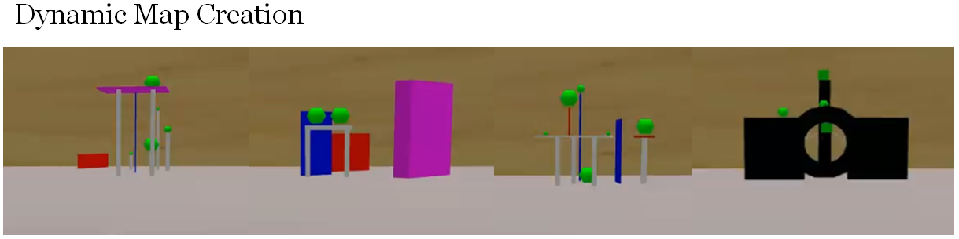

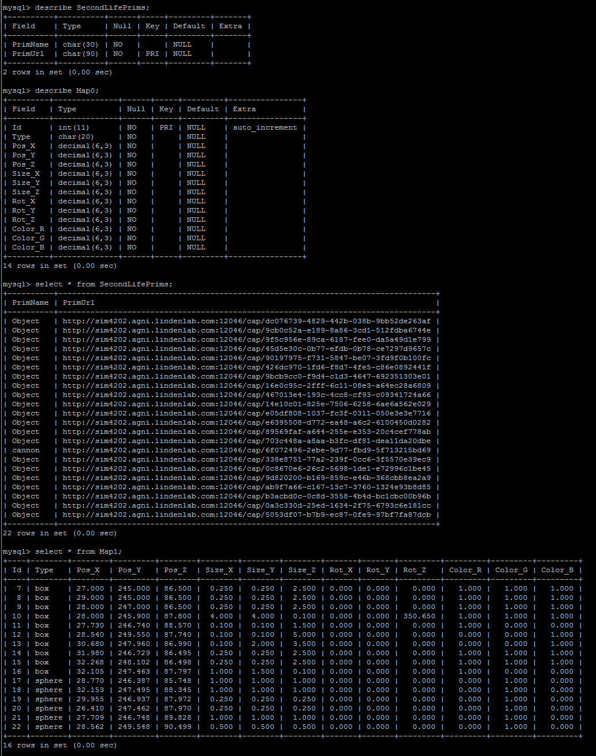
Example of the server state information
Top: Table descriptions, Middle: Active Prims in SL, Bottom: A map represented in table form

Lessons Learned
During the course of the project there were multiple problems encountered. The main areas for these problems were in the design of the collision detection system and the design of the map transition system and their interactions. The collision detection system consists of Second Life invoked methods which allow for objects to respond whenever they are in contact with other objects. The main problem faced here was that all map objects were in contact with one another. This led to the situation where the collision event was triggered when the user had not interacted with the map. The solution to this problem was in the way that the map transition occurred, specifically finding a way to trigger the collisions during map setup but to ensure that during this time there was no effect by the collision event. The use of the Second Life timer mechanism worked here and allowed for a brief delay to allow the map to be set up and settle into a steady state position. When the timer expired at the end of the map change sequence, the next actions by the user would be recorded. In addition to the collision events, the objects themselves used the existing physics in Second Life which caused some problems for the map change mechanism. The problem here was that objects needed to have their physics turned on when the user interacted with them but needed the physics off when the server interacted with them. Use of existing property changing methods was primarily used in tandem with communication requests from the server so that it was the server interactions themselves that turned the physics on and off as required. Attached to these server events were additional methods for causing the prims to become transparent and phantom (no collisions effected them).

4.3 Risks
Risk Category | Presenting Problems | Minimize Risk
Management | - Team Dynamics  - Tracking  - Planning | - Focus on communication.  - Source Control.  - Design Meetings
Definition | - Requirements  - Experience levels | - Design Meetings  - Teamwork
Design | - Design reuse | - Using previous projects
Test | - Test Plans | - Scheduling debug sessions

4.4 Tasks
- Understand/gain background in how the Kinect and Second Life can be merged.
- Design the Client, Server, and Maps.
- Implementation of the Client, Server, and Second Life scripts.
- Test the map changes and the overall program.
- Demonstrate the working AngryPrims Game.
- Document the source code and project.

4.5 Schedule

 | Fall | Spring
1. Understanding
2. Design
3. Implement
4. Test
5. Demonstrate
6. Document

3/4 – 3/10 Preliminary Report, presentation, documentation
- 3/11 – 3/24 Setup game conditions, debugging
- 3/25 – 3/31 improve gesture cannon movement, set game physics, debugging
- 4/01 – 4/7 Design Review with instructor, debugging
- 4/08 – 4/14 debugging
- 4/15 – 4/21 debugging
- 4/22 – 4/28 debugging
- 4/29 – 5/05 Final report and presentation demonstration, update website, poster session

4.6 Deliverables
- Design Document
- Code
- Final Report
- Research Paper

5.0 Key Personnel
Christian Williams – is a senior Computer Science major in the Computer Science and Computer Engineering Department at the University of Arkansas. He has completed various programing courses, as well as courses on databases, algorithms and is currently studying formal languages. The bulk of experience for this project comes from a long and distinguished history of being an amateur video game player. Christian is responsible for developing the framework for the communication of the Kinect to the Second Life environment including the database structures and scripts needed to support the communication network.
Francis Sabado – is a senior Computer Engineering student in the Computer Science and Computer Engineering Department of the University of Arkansas. He is adept in many aspects of the field, including database management, software engineering, operating systems, web development, and computer networks. He is currently taking courses in mobile programming, artificial intelligence, and integrated circuits. His knowledge of computer languages includes C, C++, C#, Java, Perl, and Python. Most of his experience comes from his extensive knowledge of computer hardware, specifically with synchronous and asynchronous microcontrollers. As a former vice president of the game development club, he enjoys playing video games. Francis will be in charge of the game engine in the Second Life platform. He will be responsible for implementing the game structure that will be controlled via the Kinect.
Aaron Mahmoud - is a Senior Computer Science major in the Computer Science and Computer Engineering Department at the University of Arkansas. He has completed multiple courses involving programming, database management and software engineering. He will be responsible for capturing and manipulating the gestures caught through the kinect and displaying them properly in Second Life.
Dr. Craig Thompson, Mentor – Thompson is a professor in the Computer Science and Computer Engineering Department. He leads the Everything is Alive research project that is currently focusing on how to simulate pervasive computing using 3D virtual worlds.

6.0 References
[1] http://www.xbox.com/en-US/kinect
[2] http://nwn.blogs.com/nwn/2011/02/kinect-in-second-life-viewer.html
[3]http://ict.usc.edu/projects/gesture_emotion_transference_using_microsoft_kinect_and_second_life_avatars/

